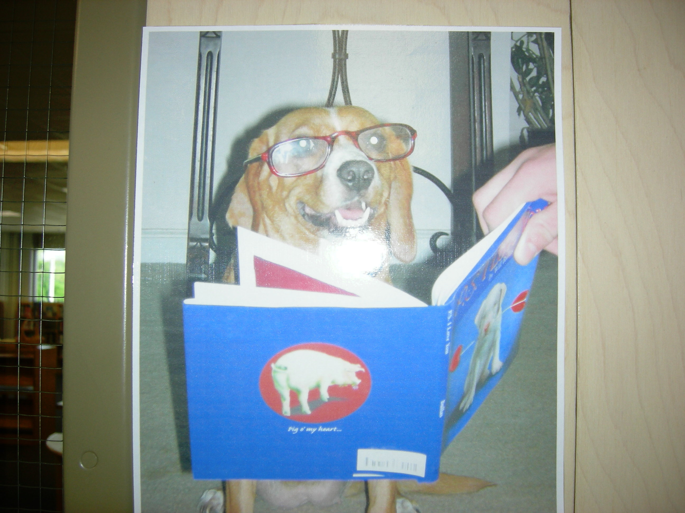
Literary
Lunch
Application
Form

Name: ______________________ Grade: _____

Tell me WHY you want to be in a Literary Lunch group:

______________________________________________________________________________________________

Name your FAVORITE book and tell me why it is your favorite:

_____________________________________________________________________________________________________________________________________________

Lunch groups typically last 6-8 weeks. If you don’t get in a group at the beginning of the school year, you will be asked to join one later in the year!

I understand that to be included in a Literary Lunch group I must complete all of my schoolwork and not be failing any subject. I also understand that being in a group involves reading 20-30 pages a week in addition to my regular schoolwork. Mrs. Kelley will check with my teachers to see if I meet these requirements.

Student signature: _______________________________

